NET 377
Lab 2 – Firewall with NAT
PT Answers Document
Due: Sunday, February 8, 2026 by 11:59 pm
50 points total

Name: Sukaina Hussain

Note: All pings should succeed unless otherwise specified.
You can edit this file directly or use a different answer file. The results that you submit on D2L should be in WORD or PDF format.
Make sure your screen captures follow the guidelines in General Lab Requirements.
Fill in All Screenshots and Answers:
- On GZ-Client, execute a ping to 4.4.4.4. Take a screenshot and paste it here.
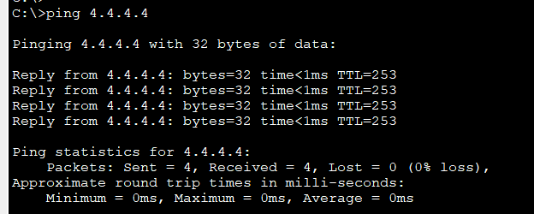

- On GZ-Client, execute ipconfig. Take a screenshot and paste it here.
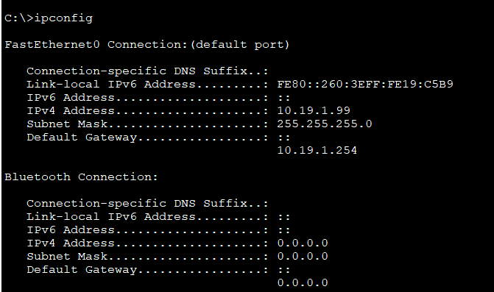

- On GZ-Server, execute a ping to 5.5.5.5. This should fail (Req. 5). Take a screenshot and paste it here.
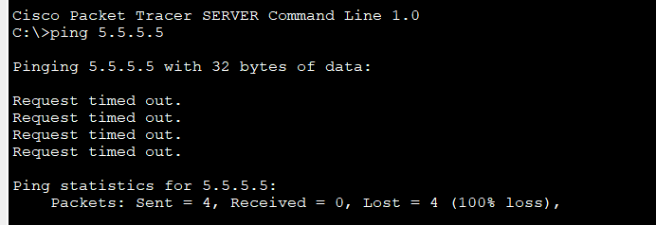

- On Internet, execute show ip route. Take a screenshot and paste it here.

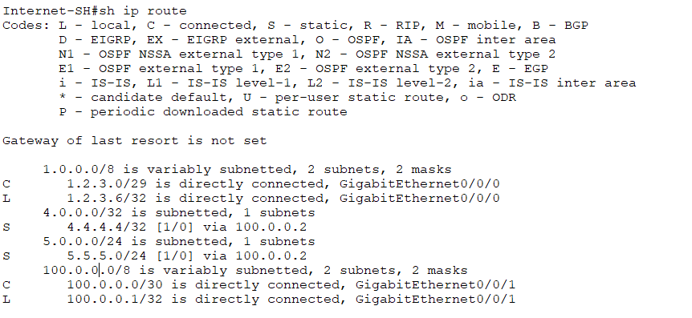

- On GZ-Firewall, execute show route. Take a screenshot and paste it here.
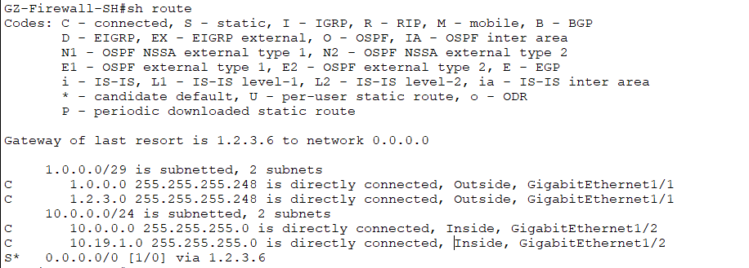

- On Public-Server router, execute show run | include username. Take a screenshot and paste it here. This will demonstrate that you have set a username and password.
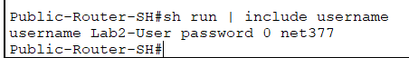

- On GZ-Client, execute telnet 5.5.5.5 80. You should see a message that it is “Open”. Then type “G” and enter, which will close the connection. Take a screenshot and paste it here.
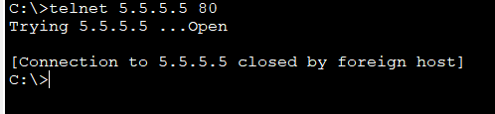

- On Internet, execute telnet 1.2.3.1 80. You should see a line ending in “Open”. Then type “G” and enter, which will close the connection. Take a screenshot and paste it here.
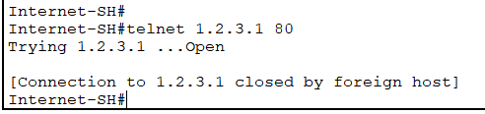

- On Public-Server router, execute telnet 1.2.3.1 80. This should timeout and fail (Req. 1). Take a screenshot and paste it here.
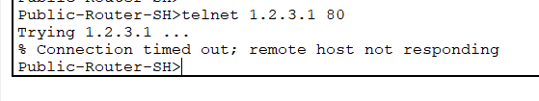

- On GZ-Client, execute ssh -l Lab2-User 4.4.4.4. This should Fail. Take a screenshot and paste it here.
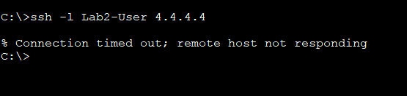

- Take one screenshot showing outputs of this sequence of commands on GZ-Server and paste into Answers:
  - On GZ-Server, execute ssh -l Lab2-User 4.4.4.4. This connection should succeed
  - Enter password for Lab2-User account
  - Execute show ip interface brief which will show interfaces on Public-Server router.
  - Execute exit which will close the SSH session.
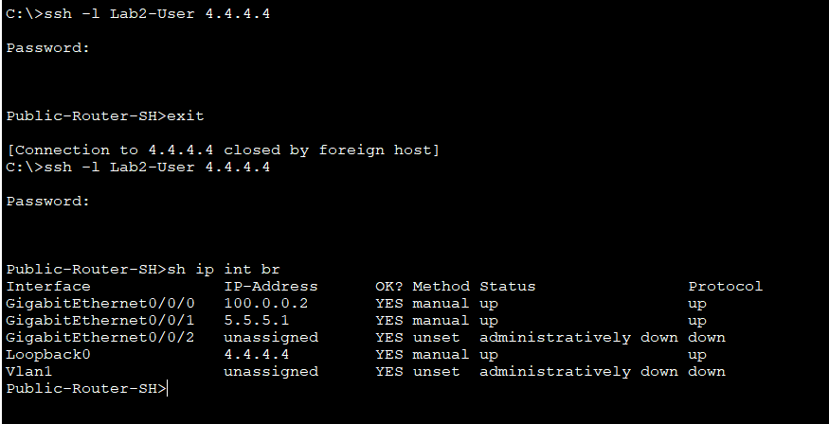

- On GZ-Firewall, execute show run object. Take a screenshot and paste it here.

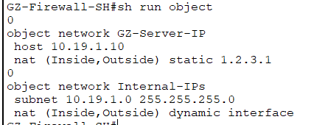

- On GZ-Firewall, execute show run nat. Take a screenshot and paste it here.

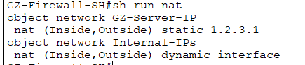

- On GZ-Firewall, execute show xlate. Take a screenshot and paste it here.
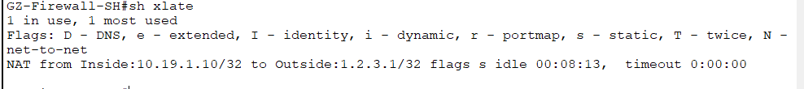

- On GZ-Firewall, execute show run | include access. Take a screenshot and paste it here.
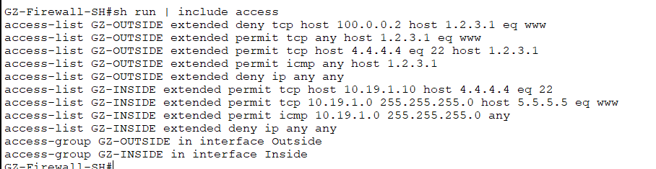

- On GZ-Firewall, execute show access-list. Take a screenshot and paste it here.
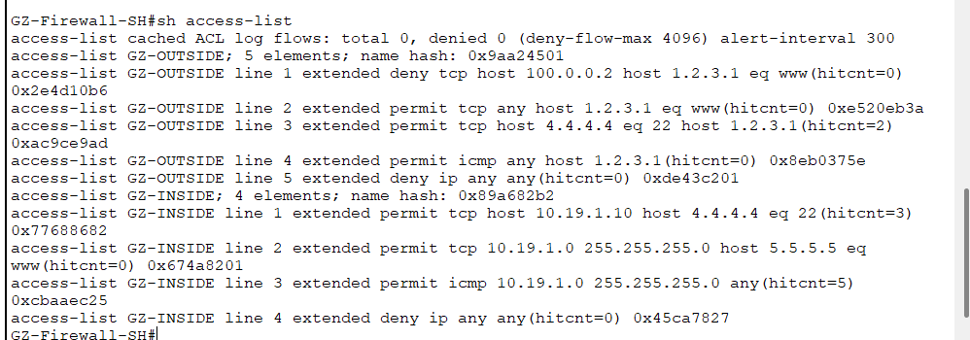

- On GZ-Firewall, execute show run | include access-group. Take a screenshot and paste it here.
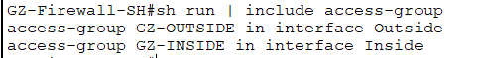

After you have provided all screenshots and answered all questions, save a copy of your Answers document in WORD or PDF format. Look through tour answer file to make sure that all screenshot output is clearly readable.
You should submit THREE documents on D2L for Lab 2:
- Your completed Answers document in WORD or PDF format.
- Your Lab2-Ruleset-Specifications Excel file created for the GZ-Firewall rulesets.
- Your PKT file.

